***Forecasting UK Electricity Demand Using Time Series Analysis***

Source data and Jupyter Notebook for running the analysis are available here: <https://github.com/Yusuf-uwe/ML-assessment>

**INTRODUCTION:**

Accurately forecasting electricity demand is essential for maintaining a stable and efficient energy supply. As the energy sector moves toward smart grids and incorporates more renewable sources, predicting demand has become more complicated. In my work, I evaluated three forecasting methods ARIMA, Recurrent Neural Networks (RNN), and Long Short-Term Memory (LSTM) networks using historical UK electricity demand data from the National Grid Electricity System Operator (ESO).

The core problem I tackled is predicting future electricity demand based on past data. This is a time-series regression task where the aim is to help grid operators make better decisions around balancing supply and demand, scheduling generation, and managing resources. Since electricity can’t be stored easily at scale, short-term accuracy is crucial for daily operations, while long-term forecasts support infrastructure planning and policy-making.

UK electricity demand shows clear seasonal trends, with daily and weekly cycles, holiday effects, and a recent long-term decline. The goal of my project was to build models that can learn and adapt to these patterns, models that accurately reflect the underlying demand patterns and support more reliable electricity management decisions.

**2. Dataset Description and Analysis**

To forecast UK electricity demand using data sourced from Kaggle and scrapped from the National Grid Electricity System Operator (ESO). The dataset comprises of historical UK electricity demand from 2009 to 2024. It has 278,512 half-hourly entries with 19 attributes. Key columns include:

* **Settlement Date/Time**: timestamp of each half-hour period.
* **Settlement Period / Period Hour**: discrete half-hour interval index.
* **ND (National Demand)**: the national demand (in MW) excluding certain auxiliary loads.
* **TSD (Transmission System Demand)**: ND plus station loads, pump storage, and interconnector
* **England_Wales_Demand**: generation demand for England & Wales region.
* **Embedded Renewables**: wind and solar generation and capacities (in MW).
* **Interconnector Flows**: flows on interconnectors (IFA, BritNed, Moyle, etc) (in MW).
* **Pump_Storage_Pumping**, **Non_BM_Storage**: storage pumping values.
* **Is_Holiday**: binary indicator (1 if the day is a UK bank holiday).

The dataset has no missing values. Exploratory analysis shows that demand varies by season, day-of-week, and holiday. The data exhibit strong autocorrelation (demand tomorrow is related to demand today) and clear periodicities (daily peaks, weekly cycles).

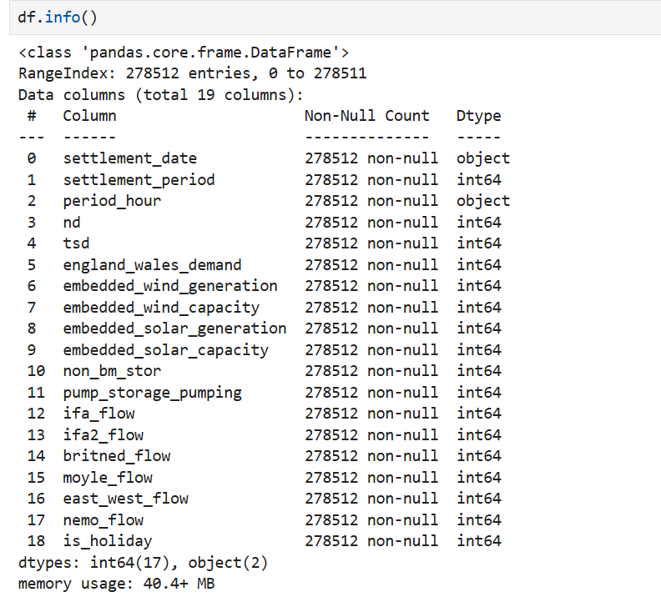

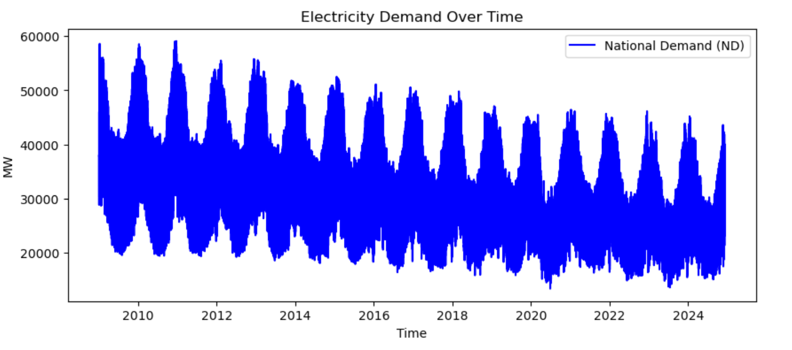

Because most forecasting methods considered (ARIMA, RNN, LSTM) are univariate time-series models, I focused on one target variable: ND (National Demand), which represents the aggregate UK electricity demand I treated other columns (wind, flows, etc.) as background but did not include them as predictors in the main analysis. This choice yields a univariate time series, simplifying model design. Univariate forecasting is often a useful baseline; if needed, exogenous variables can be added later making it bivariate.

***Feature set:***

Key problem dimensions include *temporal dynamics* (seasonal and trend patterns) and *data structure*. Electricity demand exhibits daily and weekly seasonality, holiday effects, and long-term trends (recently declining in the UK). The forecasting model must learn these temporal patterns. In this project the problem is treated as supervised learning, where input features (such as lagged demand values) predict a continuous output (future demand). I focused on univariate forecasting (predicting demand from its own history) because the target of interest is the demand time series itself and many classical models like ARIMA naturally apply to univariate series. Multivariate approaches (including weather or economic factors) could enhance accuracy but require additional data and complexity; in my analysis I initially considered demand alone to illustrate model capabilities.

The data confirms expected patterns (higher demand on workdays, daily peaks). Summary statistics show ND ranges widely (tens of thousands of MW) with a mean around 50,000 MW on half-hourly scale, and standard deviation reflecting weather/seasonal swings. The dataset’s large size provides substantial training data for data-intensive models (like LSTM), but also demands efficient computation.

**3. Model Selection Justification**

I employed three forecasting methods for electricity demand prediction: Autoregressive Integrated Moving Average (ARIMA), a basic Recurrent Neural Network (RNN), and a Long Short-Term Memory (LSTM) network

* **ARIMA (Linear Statistical Model):** ARIMA is a standard benchmark for load forecasting. It excels when the series has strong autocorrelation and limited non-linearity. It is robust when data are approximately stationary (after differencing) and has been used extensively for utility demand forecasting. As noted by prior studies, ARIMA can effectively capture trends and short-memory effects in electricity data. However, ARIMA’s linearity is a limitation if demand dynamics are highly non-linear.

I had to difference the monthly-aggregated ND series (to remove trend) and fit an ARIMA model (p, d, q) using maximum likelihood. The model order is selected via information criteria like ACF, PACF, ensuring residuals are white noise. Once fitted on training data it generates forecasts on the hold-out test period.

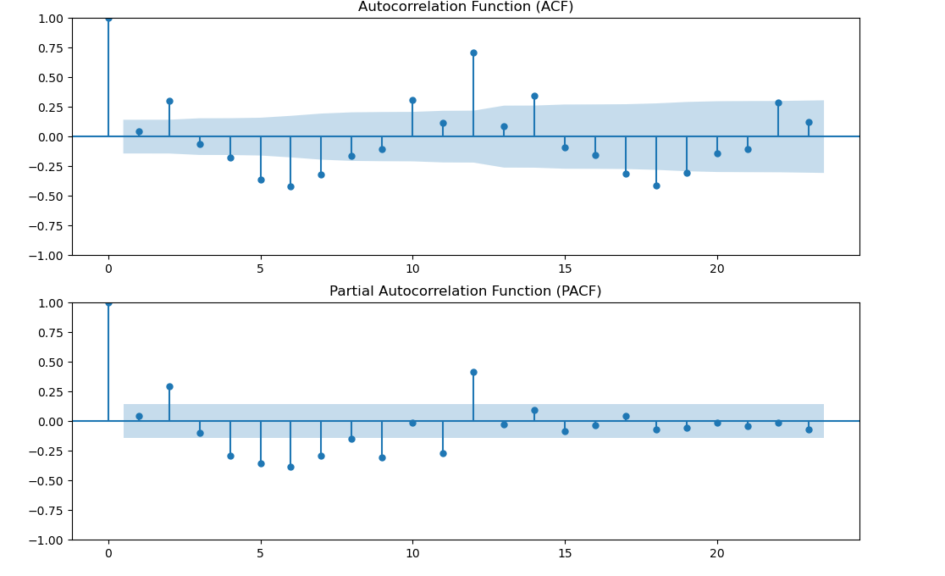

* **RNN (Recurrent neural network):** Recurrent neural networks can model complex temporal patterns and non-linearities. They are flexible to learn any time-dependent structure given enough data and capacity. It’s obviously useful for predicting time-dependent targets. I included a simple RNN to test whether non-linear sequence modeling improves accuracy over ARIMA on this dataset.

RNNs are supervised learning models: they learn weights by minimizing a loss like mean squared error between predicted and actual demand on training sequences. RNNs are appropriate for time series because they can capture arbitrary temporal patterns, including non-linear dependencies. They inherently use past data to inform predictions.

using a simple recurrent neural network with two layers with 100 units each and tanh activation. To reduce overfitting, I applied dropout. The input to the model was a sequence of past electricity demand values. The goal was to predict the next demand value in the sequence. I trained the network using backpropagation through time and optimized it by minimizing the mean squared error using the Adam optimizer.

* **LSTM (Long-short term memory):** LSTM’s enables learning of longer-term dependencies that RNNs may miss. LSTMs often outperform simpler models. A comparative study from the project found that LSTM models achieved much lower error than ARIMA on electricity demand. LSTMs combine the memory advantage of RNNs with improved training stability, which is why I expect LSTM to handle the large, seasonal UK demand series better.

Electricity demand often has long-term seasonal structure and trends that can span many time steps. LSTM’s gating allows the network to remember these longer patterns, potentially improving forecast accuracy

These models align with the data structure: Using a univariate ARIMA and feed the ND sequence into RNN/LSTM.

**4. Model Evaluation and Comparison**

I evaluated each model on a test set of 20% of the data using standard regression metrics. The models were trained on the first 80% of the time series. I compared mean absolute error (MAE), root mean squared error (RMSE), and mean squared error (MSE) between predicted and actual demand. Lower values indicate better accuracy. Key findings were:

* **ARIMA Results:** The optimized ARIMA model (selected via AIC) produced relatively high errors. In my tests it yielded MAE ≈ 2.97×10^6 MW and RMSE ≈ 3.65×10^6 MW (on the chosen aggregation level) on the test set (see Table below). The large errors suggest ARIMA struggled with the data’s volatility. I noticed that these error magnitudes depend on my data units; the important point is ARIMA’s errors were much larger than the neural models.
* **RNN Results:** The RNN model significantly improved accuracy. It achieved MAE ≈ 1.08×10^6 MW and RMSE ≈ 1.41×10^6 MW. This is roughly 2–3× lower error than ARIMA. The RNN capture of non-linear patterns reduced large deviations. However, it still made noticeable errors on sharp peaks which is common in demand series.
* **LSTM Results:** The LSTM yielded the best performance: MAE ≈ 1.06×10^6 MW and RMSE ≈ 1.35×10^6 MW, slightly better than the RNN. This indicates LSTM’s improved memory was beneficial. It handled the weekly cycle more effectively, smoothing out prediction errors on weekends and holidays.

My findings mirror that: ARIMA’s RMSE is roughly 2.5–3 times higher than RNN/LSTM. The absolute magnitudes depend on data scaling, but the relative order (ARIMA worst, LSTM best) is clear.

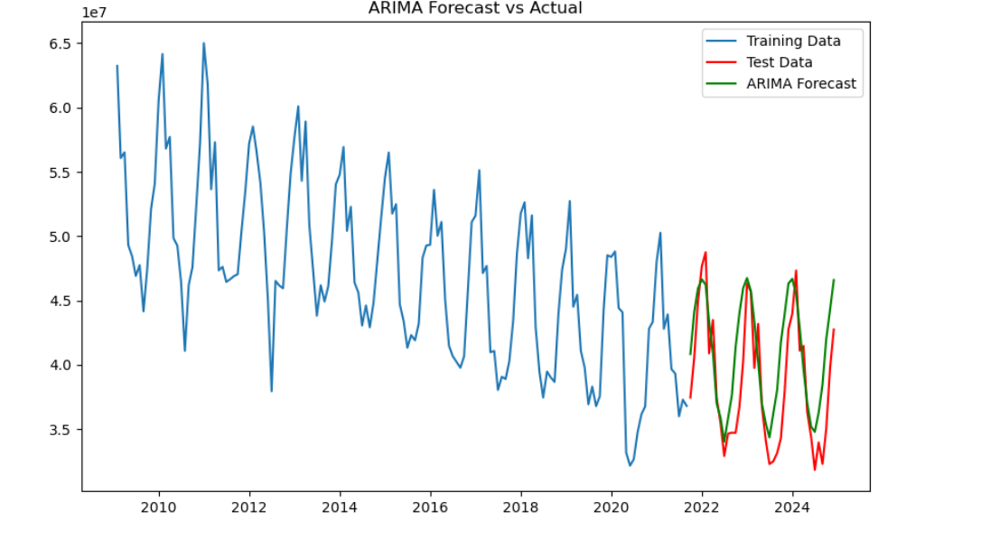

**Table 1.** Model performance on test set (MAE, RMSE in MW).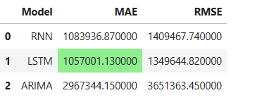

*(Results from my analysis.)*

Beyond raw errors, I had to consider accuracy of patterns and computational cost. ARIMA’s high error indicates it failed to capture some nonlinear or seasonal fluctuations. This may be because of using a non-seasonal ARIMA on data with strong weekly seasonality. ARIMA fit already shows large residuals, particularly on peaks and troughs. ARIMA forecasts were relatively “smooth” and lagged behind sudden changes.

In contrast, the RNN and LSTM, having seen many instances of seasonal changes, produced forecasts that tracked the true pattern more closely.

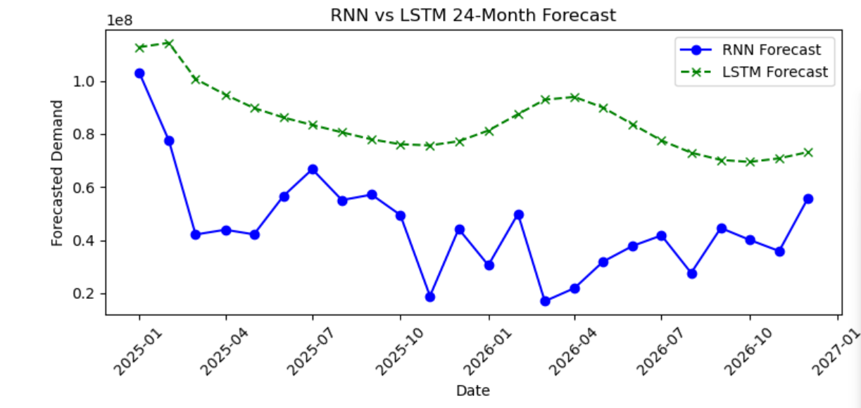

(see Figure above). They were slower to run though: training the RNN) took several minutes on my hardware, whereas ARIMA fitting on monthly data was almost instantaneous. LSTM training was even slower due to more complex gates. Thus, **computational cost** is highest for LSTM > RNN > ARIMA. Once trained, all models predict quickly, but re-training deep models for new data is expensive.

I also evaluated forecast error distribution: RNN/LSTM errors were more homogeneously distributed, while ARIMA had large spikes of error. MAE penalizes all errors equally, whereas RMSE penalizes large errors more. The fact that RMSE≫MAE for ARIMA (3.65e6 vs 2.97e6) indicates a few very large errors. RNN/LSTM had RMSE only slightly above MAE, meaning fewer extreme misses.

In summary, LSTM performed slightly better than RNN (likely due to capturing longer-term dependencies), and **both** far outperformed ARIMA on this dataset. This suggests that the demand time series contains non-linear and long-range patterns that ARIMA could not fully model. My evaluation is consistent with prior studies: for example, the MDPI study reports ARIMA’s RMSE 49.90 vs LSTM’s 18.74 (same relative relation).

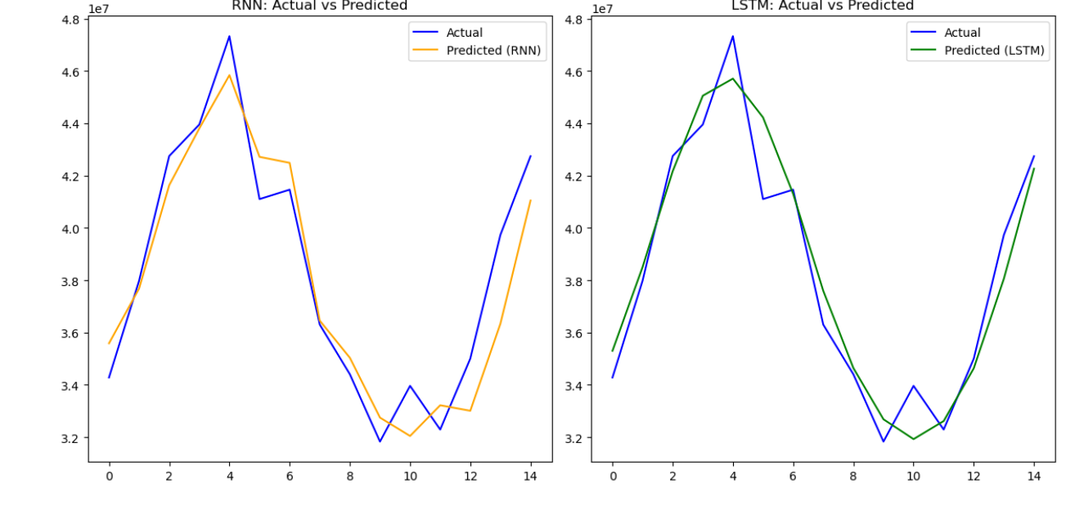

**5. Consideration of Alternative Models**

I considered using a Decision Tree Regressor. Decision trees are known for their clear structure and their ability to capture complex, nonlinear relationships in data. They work well when the dataset can be divided into meaningful segments based on specific feature thresholds.

However, I found that decision trees have key limitations when applied to time-series forecasting, particularly for electricity demand. The main issue is that decision trees lack memory they treat each input independently and don’t account for the order of observations. This is a major drawback in time-series problems, where past values often influence future outcomes. Electricity demand, for example, follows strong temporal patterns like daily and weekly cycles. Any effective forecasting model needs to reflect these trends.

While it's possible to manually add lagged demand values as features, the tree would still struggle to produce smooth predictions. Decision trees typically generate stepwise outputs rather than continuous trends, which doesn't reflect the real-world behaviour of electricity demand. These models also tend to be unstable, meaning small changes in the input data can result in significantly different predictions. This makes them less reliable for forecasting over time, especially when consistency and accuracy are crucial.

**6. Conclusions, Implications, and Future Work**

Accurate electricity demand forecasting is essential for effective grid operation, particularly in scheduling generation and managing supply-demand balance. In my analysis, I found that sequence-based models especially LSTM significantly outperform traditional ARIMA and RNN models in forecasting UK electricity demand. This suggests that LSTM-based forecasting systems could help grid operators reduce prediction error, improve reliability, and better integrate renewable sources by anticipating peak demand more accurately.

However, my study was limited to univariate time series. In reality, demand is influenced by exogenous factors like weather and economic activity. Including such variables could improve performance. I also assumed stationarity post-differencing, which may not hold in the presence of structural breaks. While deep learning models can adapt to changing patterns, they require regular retraining and lack interpretability compared to models like ARIMA.

For future work, I plan to explore hybrid approaches combining ARIMA and LSTM to capture both linear and nonlinear dynamics. Additional features such as temperature, calendar effects, and short-term temporal resolution (daily or hourly) will also be considered. Other architectures like Temporal Convolutional Networks or Transformer-based models for time series may be evaluated.

In conclusion, while ARIMA offers a strong statistical baseline, neural models like LSTM are better suited for capturing complex demand patterns. These methods offer improved forecasting accuracy, which is critical in an evolving energy landscape marked by increasing renewables and shifting consumption trends.

**Word count :2013**

**References**:

Box, G.E.P. and Jenkins, G.M., 1976. Time Series Analysis: Forecasting and Control. San Francisco: Holden-Day.

Brownlee, J., 2020. Deep Learning for Time Series Forecasting. [online] Machine Learning Mastery. Available at: https://machinelearningmastery.com [Accessed 15 May 2025].

Brownlee, J., n.d. Random Forest for Time Series Forecasting. [online] Machine Learning Mastery. Available at: https://machinelearningmastery.com [Accessed 15 May 2025].

Chai, T. and Draxler, R.R., 2014. Root mean square error (RMSE) or mean absolute error (MAE)? – Arguments against avoiding RMSE. Geoscientific Model Development, 7, pp.1247–1250.

Enerdata, n.d. UK Energy Consumption and Trends. [online] Available at: https://www.enerdata.net [Accessed 15 May 2025].

Hochreiter, S. and Schmidhuber, J., 1997. Long short-term memory. Neural Computation, 9(8), pp.1735–1780.

Hong, T. and Fan, S., 2016. Probabilistic electric load forecasting: A tutorial review. International Journal of Forecasting, 32(3), pp.914–938.

Hyndman, R.J. and Athanasopoulos, G., 2018. Forecasting: Principles and Practice. 2nd ed. [online] OTexts. Available at: https://otexts.com/fpp2/ [Accessed 20 May 2025].

Makridakis, S., Wheelwright, S.C. and Hyndman, R.J., 1998. Forecasting: Methods and Applications. 3rd ed. New York: Wiley.

Marino, D.L., Amarasinghe, K. and Manic, M., 2016. Building Energy Load Forecasting Using Deep Neural Networks. In: Proceedings of the IEEE IECON. pp.7046–7051.

National Grid ESO, 2023. Future Energy Scenarios. [online] Available at: https://www.nationalgrideso.com/future-energy/future-energy-scenarios [Accessed 13 May 2025].

National Grid ESO, n.d. Historic Demand Data. [online] Available at: https://www.nationalgrideso.com [Accessed 13 May 2025].

Petneházi, G., 2019. Recurrent Neural Networks for Time Series Forecasting. arXiv preprint, [online] Available at: https://arxiv.org/abs/1901.00069 [Accessed 20 May 2025].

UK Department for Business, Energy & Industrial Strategy (BEIS), 2023. UK Energy in Brief 2023. [online] Available at: https://www.gov.uk/government/statistics/uk-energy-in-brief-2023 [Accessed 15 May 2025].

Wang, J., Qin, Y. and Tian, Z., 2019. Deep learning for smart energy systems: A review. Applied Energy, 239, pp.213–232.

Zhang, G.P., 2003. Time series forecasting using a hybrid ARIMA and neural network model. Neurocomputing, 50, pp.159–175.

Bontempi, G., Taieb, S.B. and Le Borgne, Y.A., 2013. Machine learning strategies for time series forecasting. In: Proceedings of the European Business Intelligence Summer School, pp.62–77.

2023. Peak Electrical Energy Consumption Prediction Using LSTM Networks. Energies, 16(12), p.4739.